1. Open apache 5.5 folder
2. Click on bin folder and in that click on apachejmeter executable jar file
3. open webtours folder
4. 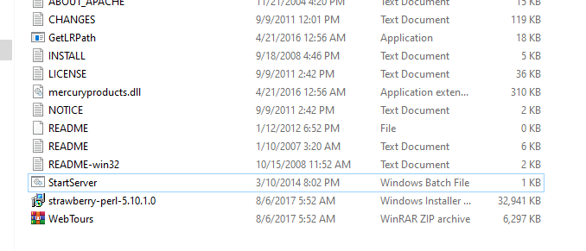
5. Click on webtours start server.(use ip address which came in the cmd if not working go to 7th step)
6. 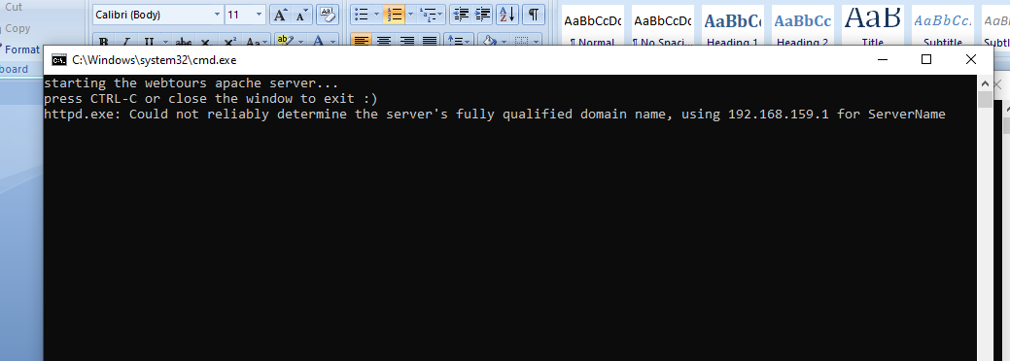
7. Open jmeter.
8. Open cmd and type ipconfig
9. 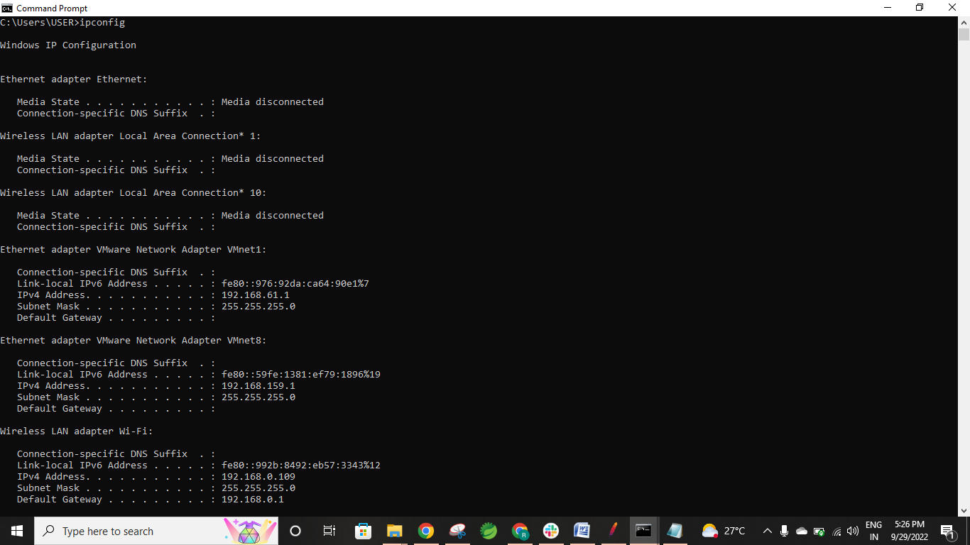
10. Open a chrome and a window and enter the ip address of the wifi like <http://192.168.0.109:1080/webtours/>
11. Go to new and create a test plan.( jmetercasestudyonwebtourss)
12. Right click on test paln add thread group—Threads—Threadgroup
13. First we have opened the website and we want to record the steps manually, so we right click on the page inspect and go to network and refresh the page.
14. Select the below request in picture.
15. 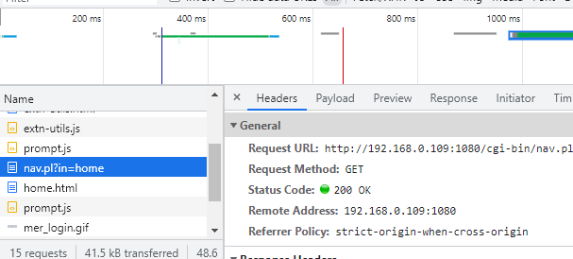
16. Right click on thread group select sampler--- HTTP Request.
17. Copy url like the way in given Picture.
18. 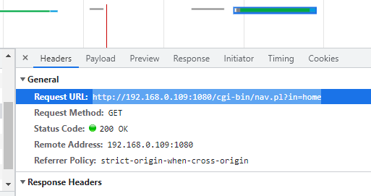
19. Using above url
20. Past the items as below
21. Protocol –http, ip—192.168.0.109, portnumber—1080, method – get, path(resource)—like in below
22. 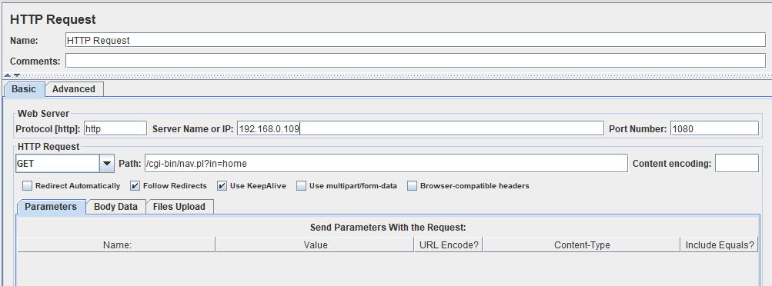
23. Right click on Thread group add Listners--- View Result Tree and run.
24. Click on view result tree – click on http request—click on response body— in that copy value =”OAA”
25. 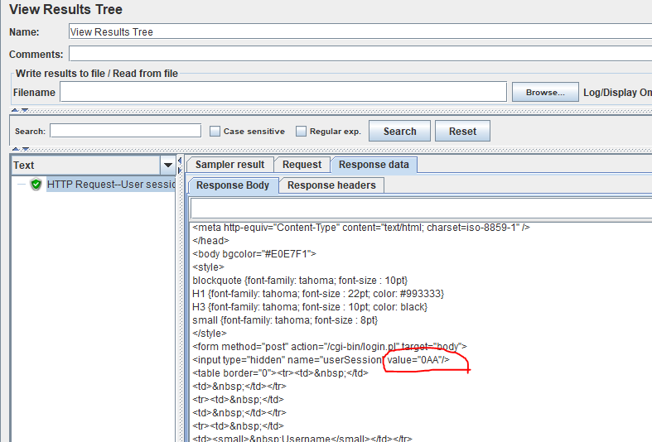
26. Right click on HTTP request – select post processor—Regular expression extractor.
27. 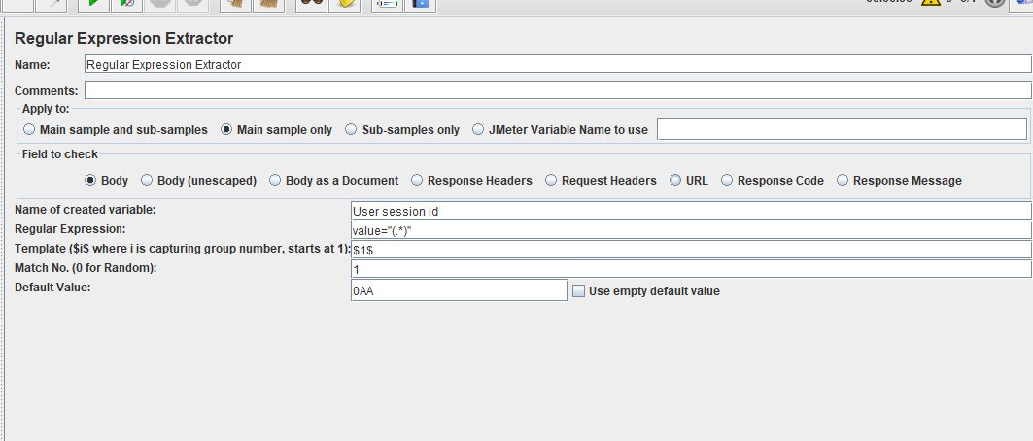
28. 1st-Create a variable name as ur wish.
29. In Regular Expression paste the value – (Value=”OAA”)—we have covert –( value=”(.\*)”) as shown above.--- Template as ($1$) and matchno as (1), default value as –(OAA).
30. Before logining in into the website clear everything.
31. 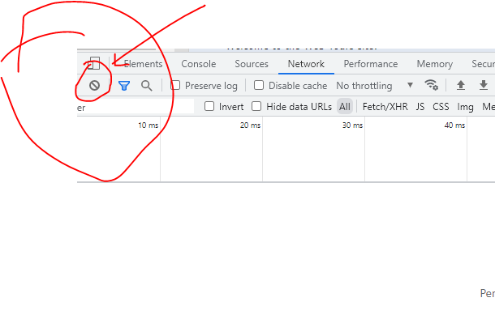
32. Enter the user credentials like Username and Password and click on login button.
33. Click on Login.pl
34. 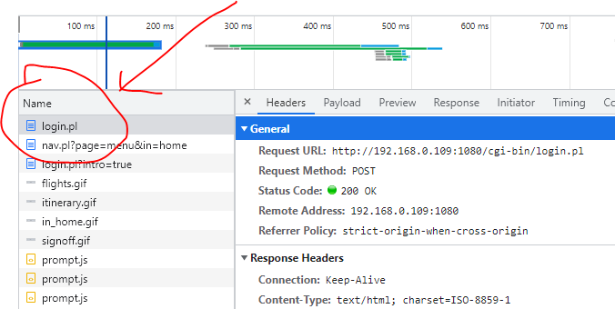
35. 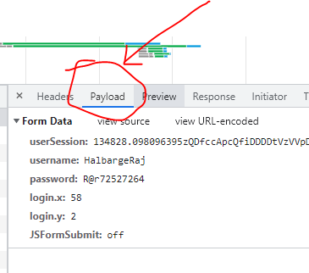
36. After click on view source.
37. Copy paste the usersession..as below pic.
38. 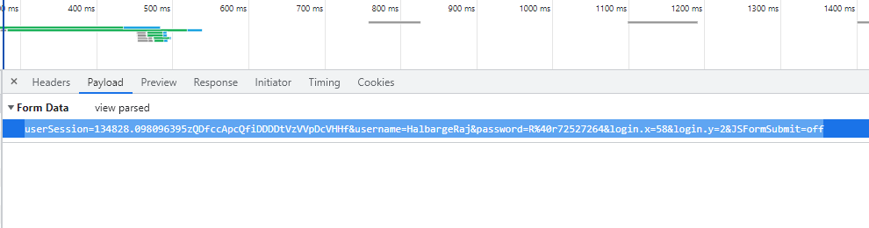
39. Creat an HTTP Request and add things like below pic from the header of point 34
40. 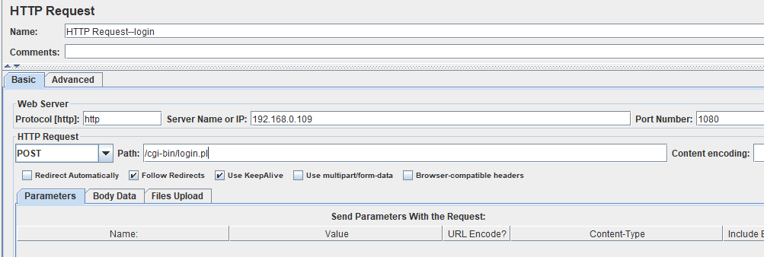
41. Point number 37 copy user session and click on add from clipboard in HTTP request—login. as below picture.
42. 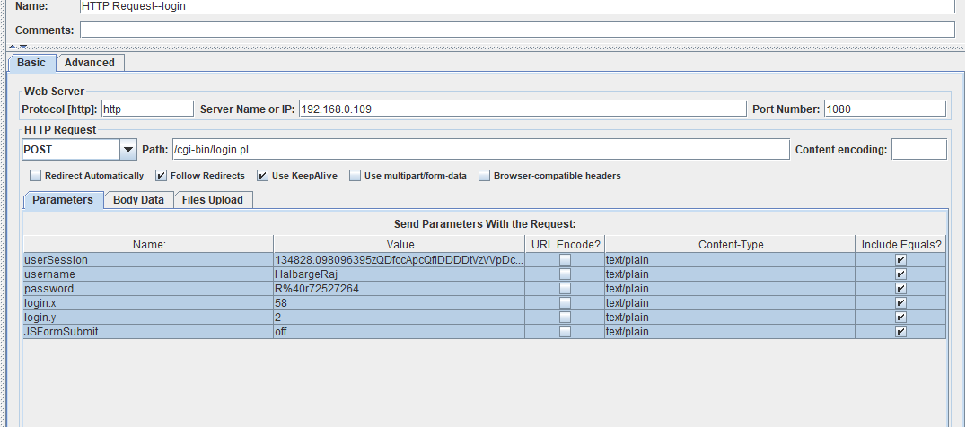
43. In pic 42 userSession value delete the value—copy paste the- variable name from regular expression extractor as in pic 27. And paste it as ${user session id} as below
44. 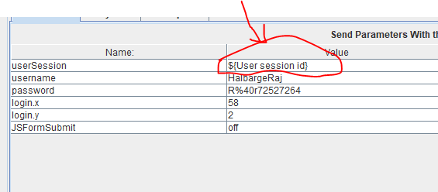
45. Add new HTTP request and copy paste from the payload like above userssion as below pic.
46. 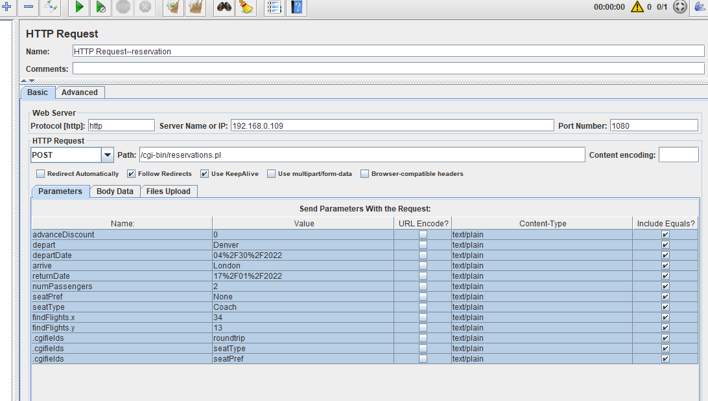
47. Add new HTTP request for selecting the flights.—and add these credentials like below
48. 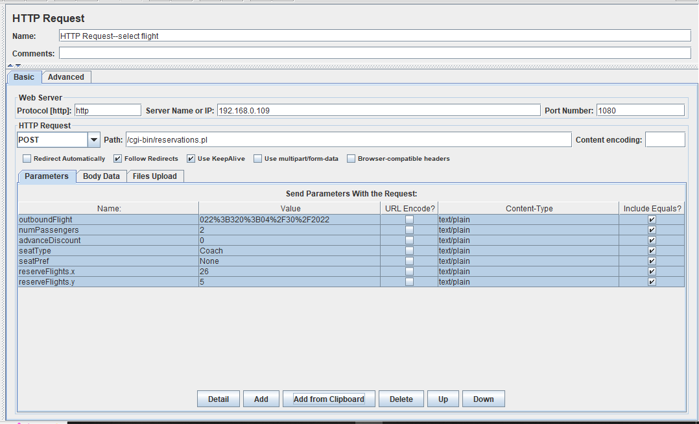
49. Go to chrome and do ittttt-m add card details
50. 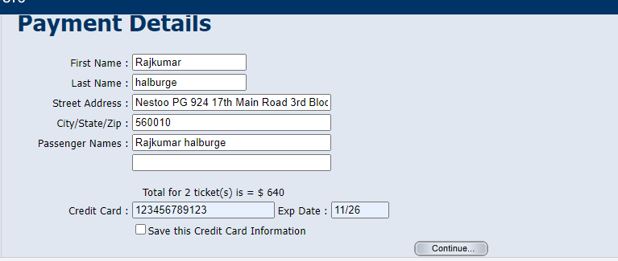
51. Add new HTTP request for enter card details---- and ---copy paste from the payload. Like below picture.
52. 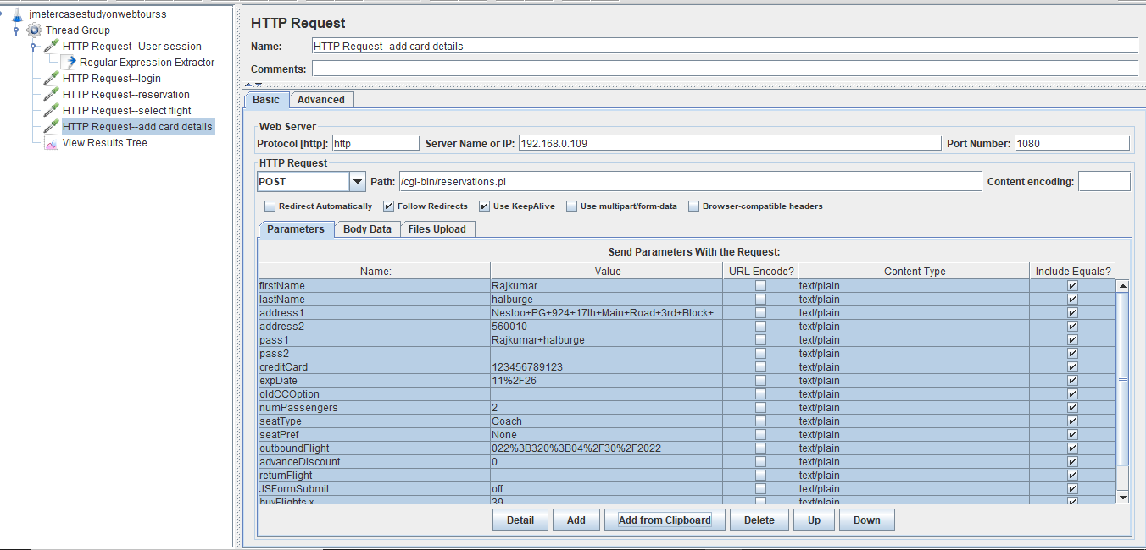
53. And clear everything and click on signoff
54. 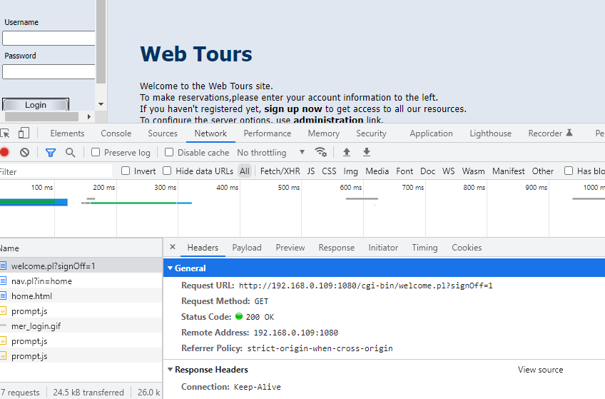
55. Create HTTP method for Signoff and add credentilss.
56. We sould go to the payload if it’s a get request……
57. 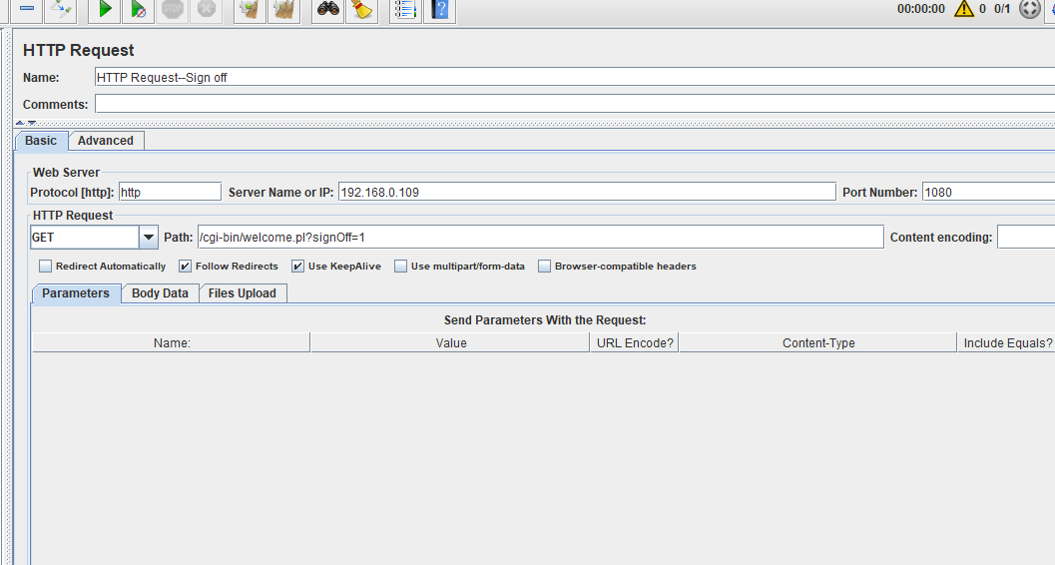
58. Go to view result tree run once
59. 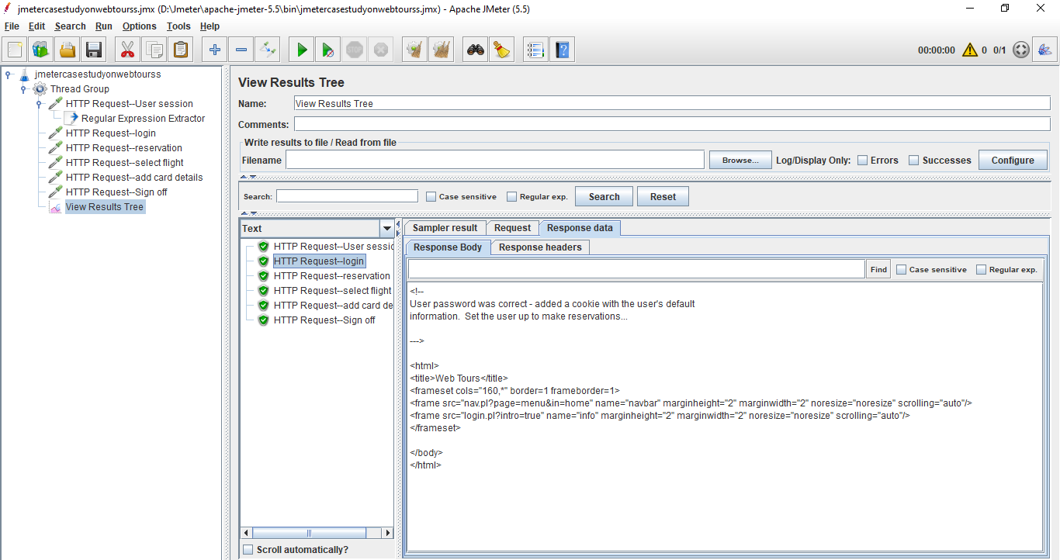
60. If you want add assertion in login like below
61. 